**Solritas – Workaround for launching “file:/” link from a web page.**

Solution from:  
<https://autohotkey.com/board/topic/71831-application-url-launch-local-application-from-browser/>  
  
**Introduction**Due to web browser security, you cannot click on a “file:/” link in a web page downloaded from a web server. Nothing happens. But, you CAN do this if the web page was itself opened locally from the filesystem. This document explains how to workaround this limitation using Autohotkey– on Windows only.

Were are going to define our own protocol named “appurl:/”. To do this, we will add a repository entry similar to the existing entry for “http”:  
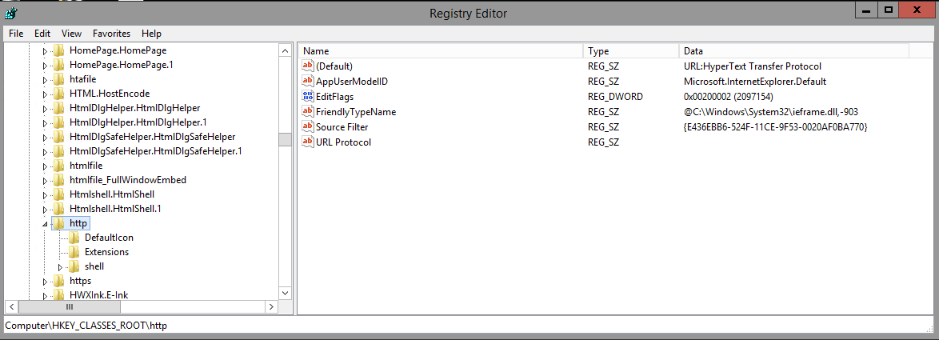  
  
  
  
1) First we create our own registry entry for our new protocol “appurl”:  
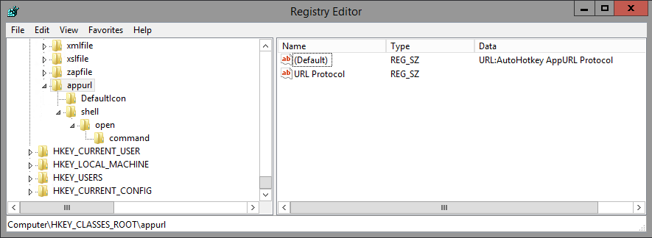  
  
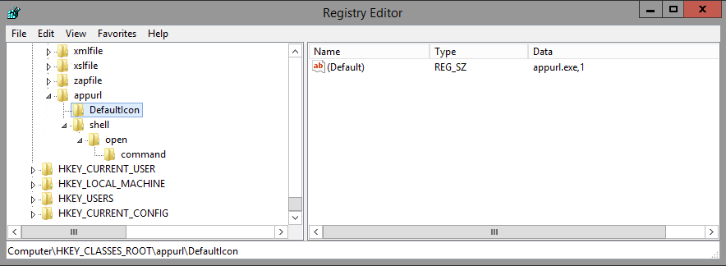  
  
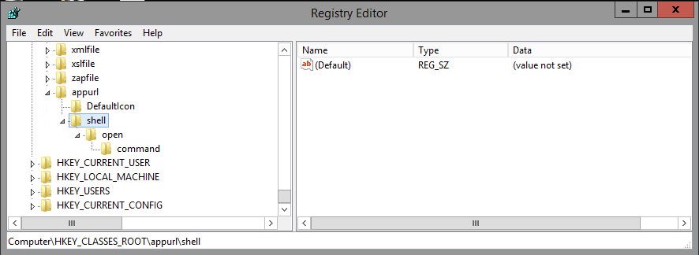  
  
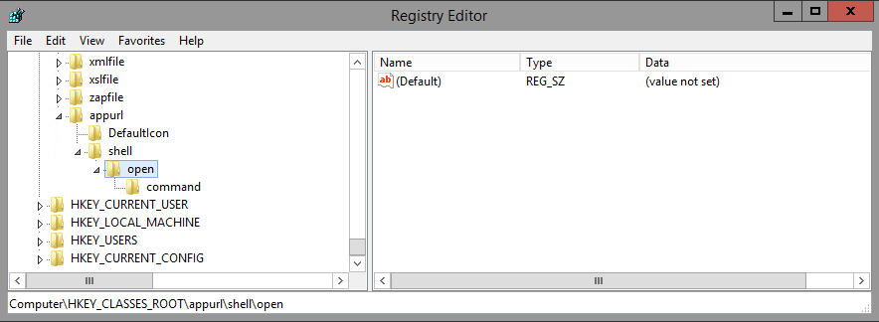  
  
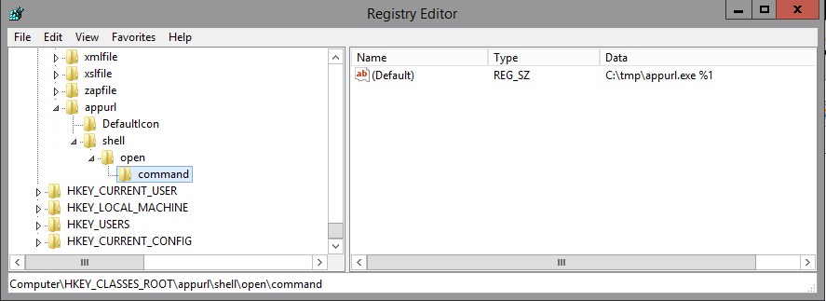  
  
**Note:** File “c:\tmp\appurl.exe” is our special exe built from an Autohotkey .ahk script. This exe will strip the leading “appurl:/” from the passed document path and then “run” the document, causing Windows to open the native application.

2) Create a Autohotkey script appurl.ahk:

|  |
| --- |
| if 0 != 1 ;Check %0% to see how many parameters were passed in  {  msgbox ERROR: There are %0% parameters. There should be 1 parameter exactly.  }  else  {  param = %1% ;Fetch the contents of the command line argument  appurl := "appurl://" ; This should be the URL Protocol that you registered in the Windows Registry  IfInString, param, %appurl%  {  arglen := StrLen(param) ;Length of entire argument  applen := StrLen(appurl) ;Length of appurl  len := arglen - applen ;Length of argument less appurl  StringRight, param, param, len ; Remove appurl portion from the beginning of parameter  }  decoded := uriDecode(param)    Run, %decoded%  }  ; https://autohotkey.com/board/topic/78948-convert-%20-etc-in-urls/  uriDecode(str) {  Loop  If RegExMatch(str, "i)(?<=%)[\da-f]{1,2}", hex)  StringReplace, str, str, `%%hex%, % Chr("0x" . hex), All  Else Break  Return, str  } |

**Note:** This includes a URL decode function stolen from <https://autohotkey.com/board/topic/78948-convert-%20-etc-in-urls/>

3) Build appurl.exe from appurl.ahk (see <https://autohotkey.com/docs/Scripts.htm#ahk2exe>):

|  |
| --- |
| "c:\Program Files\AutoHotkey\Compiler\Ahk2Exe.exe" /in "appurl.ahk" |

(Our registry entry requires that we copy this to C:\tmp).  
  
Testing appurl.exe:  
c:\tmp\appurl.exe "appurl://D:/tmp/In VKnow week of April 16.msg"  
The “appurl://” is stripped-off by appurl.exe and then it launches the file. In this example “running” an msg file like this launches Outlook.

4) Update Solritas file example/solr/collection1/conf/velocity/richtext_doc.vm to replace “file:/” with “appurl://”:

|  |
| --- |
| ## Row 2?: ID / URL  <div>  ## JeremyC. Id hyperlinked, to try and launch native application.  ##Id: #field('id')  #if($doc.getFieldValue('id'))  #set($id_link = $doc.getFieldValue('id'))  #set($id_link2 = $id_link.replace("file:/","appurl://"))  #set($id_decoded = $link.decode($id_link2))  #end  Id: <a href="${id_link2}" target="_NEW">${id_decoded}</a>  </div> |

5) A Solritas search result now looks like this:  
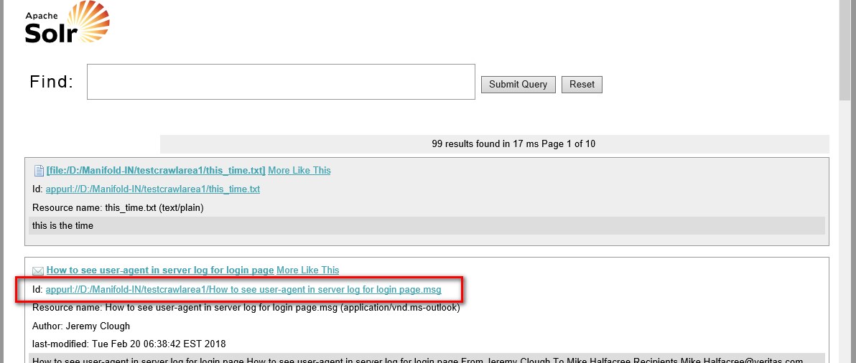  
…and clicking on this link will launch Outlook (in this example):  
  
  
*JeremyC 7-6-2018***END**